**Assignment 2: Output**

* Log in as “Admin” and go to “Employee System” and input 1 to check “Manager worker”.

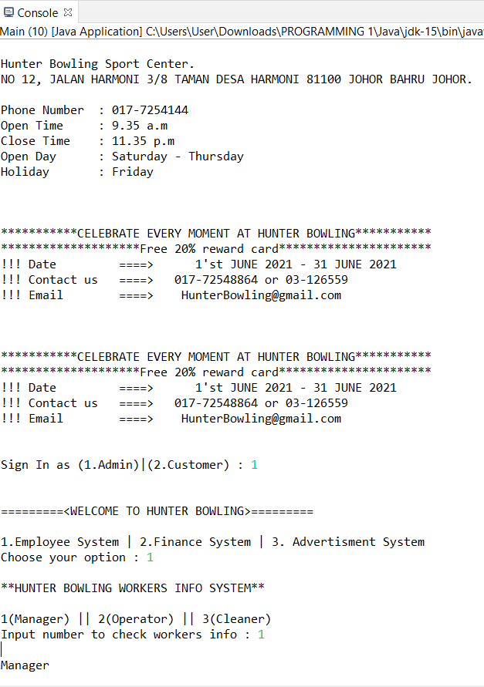

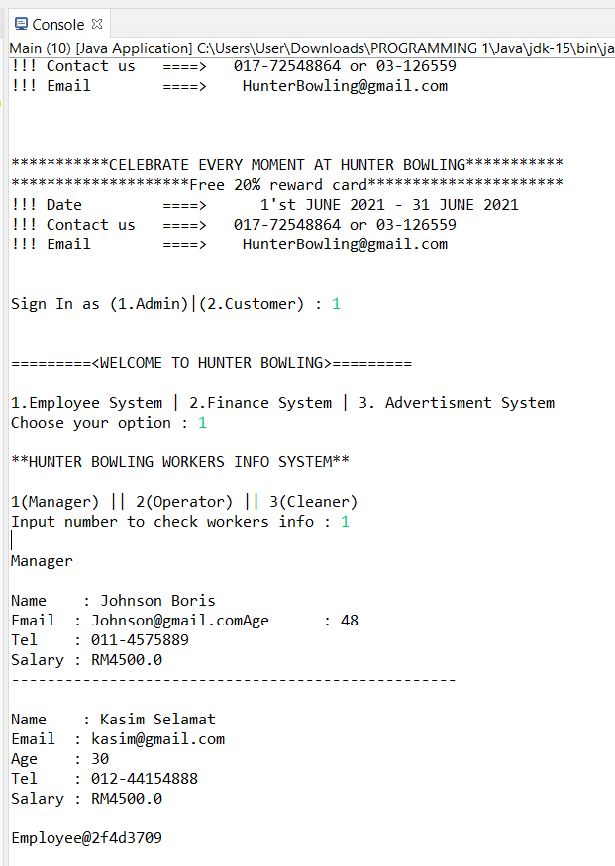

* Log in as “Admin” and go to “Adverstiment System”.

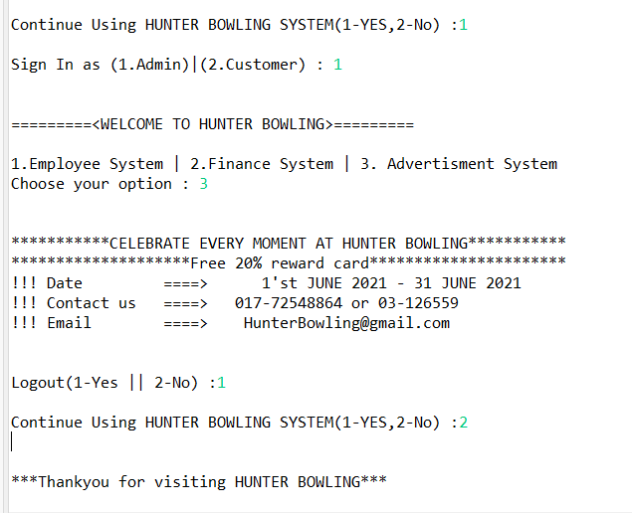

* Log in as “Customer” and go to “Member Registration”.

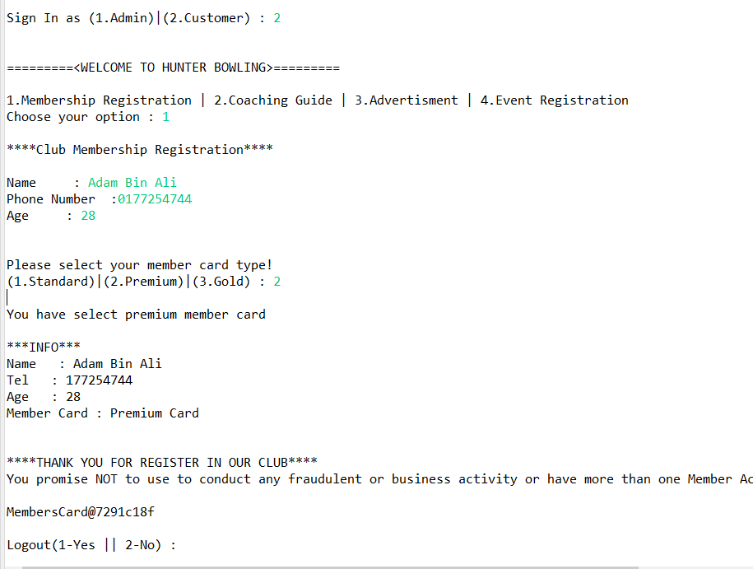

* Log in as “Customer” and go to “Coaching Guide” and choose month training period (6,9).

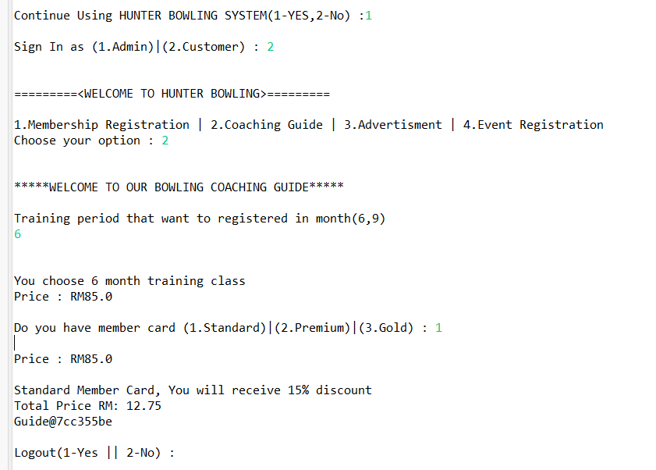

* Log in as “Customer” and go to “Event Registration” and choose member.

